**Tutorial 7-part A**

1. With example, describe each of the components of MVC.

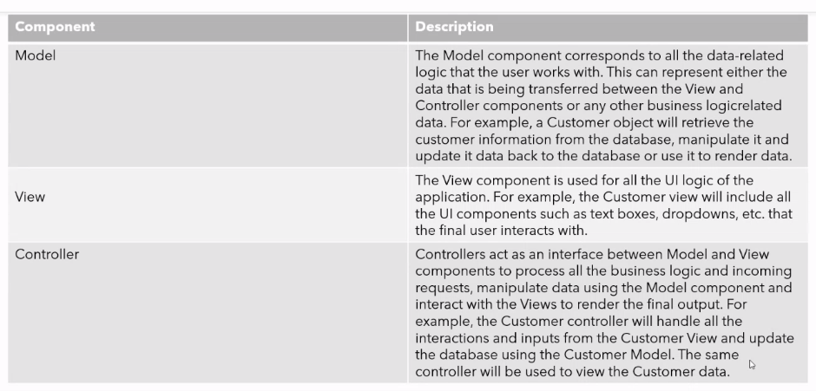

1. Specify the steps on how to implement MVC with RequestDispatcher.

1. Define beans to represent the data

2. Use a servlet to handle requests

3. Populate the beans

4. Store the beans in the request, session or servlet context

5. Forward the request to a JSP page

6. Extract the data from the beans

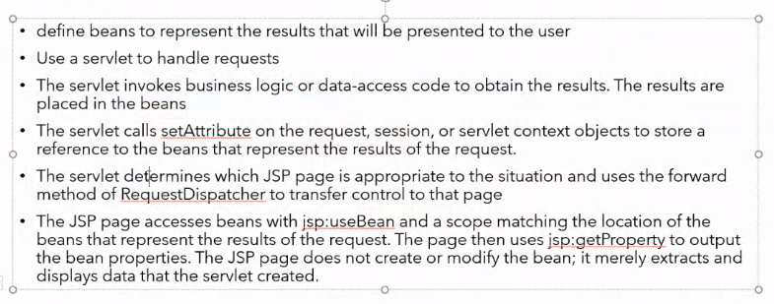

1. How a servlet and JSP communicate using the RequestDispatcher object?

* By using RequestDispatcher object, a servlet can forward the request to a JSP page (or can also be a servlet or HTML file).
* E.g. *public void forward(ServletRequest request, ServletResponse response) throws ServletException,java.io.IOException*
* A servlet can also include in its response the content generated by another resource (JSP, servlet, HTML file)
* E.g. *public void include(ServletRequest request,ServletResponse response) throws ServletException,java.io.IOException*

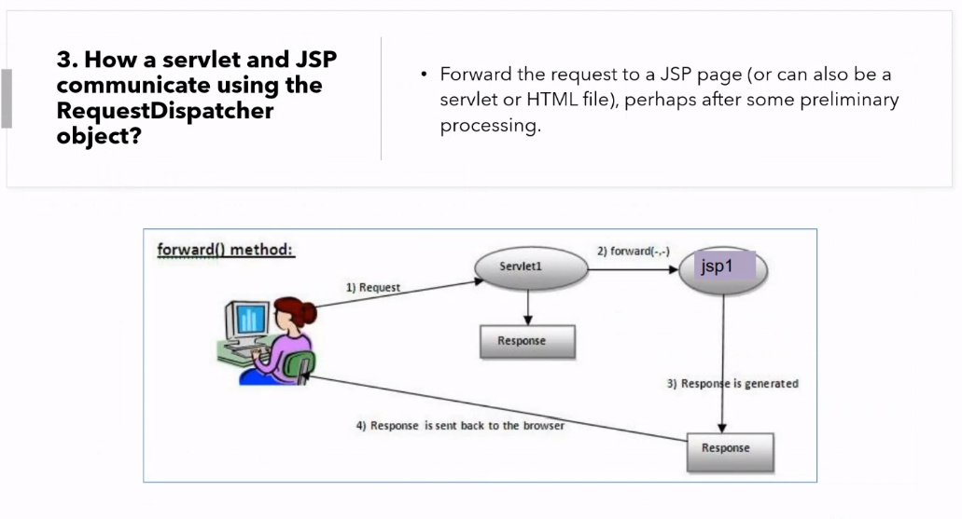

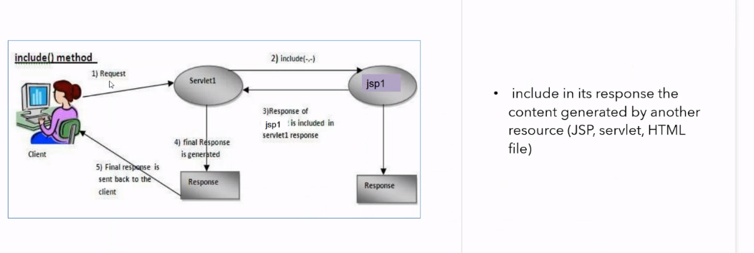

1. How a servlet redirects a response to another resource? why?

* A servlet can redirect a response to another resource (JSP, servlet, HTML file) by calling the HttpServletResponse.sendRedirect method.

1. Specify the role of entity manager.

* Run ad-hoc queries.
* Fetch objects given primary keys.
* Automatically build collections (lists).
* Manage the objects once they have been loaded, i.e. the entity manager can observe changes made to objects and arrange to synchronize persisted versions of the data with the updated in memory object

1. What is the purpose of Java Transaction API (JTA) and how it is used

